 | Coledale Public School – School Song  Written by Kenny Bartley & Lana Patrin  2012 |  | 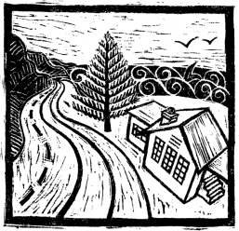
Verse 1:  In a southern coastal suburb  Between escarpment and the sea  In 1912 they built our school  Now it’s part of history  With lessons learned and friendships formed  We go to school each day  By the ocean, on a cliff  We live and learn and play |  | Verse 2:  Now it's present day our school has grown  But in spirit stays the same  Teachers, classrooms, playground, kids  In sun and wind and rain  There are the markets on a Sunday  People come from all around  And our Eco garden grows and blooms  Like a classroom in the ground
Chorus:
And we will learn to live down by the sea
At Coledale Public School
A part of the community
And we will learn to live my friends and I
Filling up with knowledge
As the whales pass by
Our days are full
At Coledale Public School.

School Song
Verse 1 – Chorus – Verse 2 – Chorus + repeat last two lines.

